BIG LAGOON UNION SCHOOL DISTRICT
GOVERNING BOARD
Tuesday, June 05, 2018, 4:30 p.m.
Big Lagoon School, Computer Lab
PUBLIC HEARING
1. Local Control Accountability Plan
2. 2017-2018 Budget
3. Educational Protection Account
4. Educator Effectiveness Expenditures

Any writings distributed either as part of the Board packet, or within 72 hours of a meeting, can be viewed at the Big Lagoon School District Office.

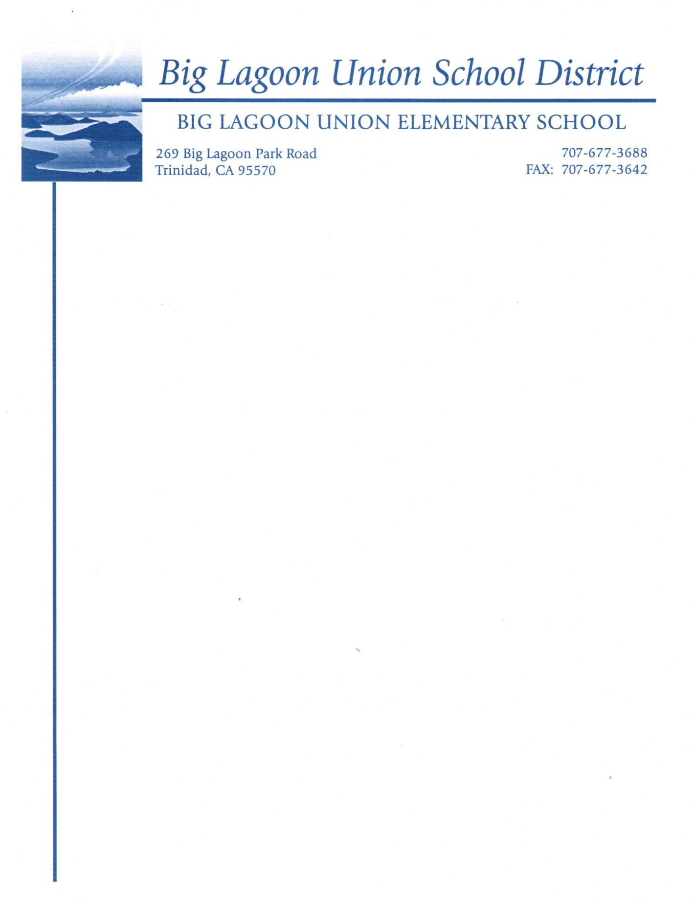
NOTICE: Any writing, not exempt from public disclosure under Government Code Section 6253.5, 6254, 6254.3, 6254.7, 6254.15, 6254.16, or 6254.22, which is distributed to all or a majority of the members of the governing board by any person in connection with a matter subject to discussion or consideration at an open regular meeting of the board is available for public inspection at 269 Big Lagoon Park Road, Trinidad, CA 95570

